CSC7053 Software Engineering

**Software Engineering Project:**

**Technopoly**



**Group 3:**

Barbara Murtland

Colette Casey

Dave Kennedy

Ismael Florit

Tim Lewis

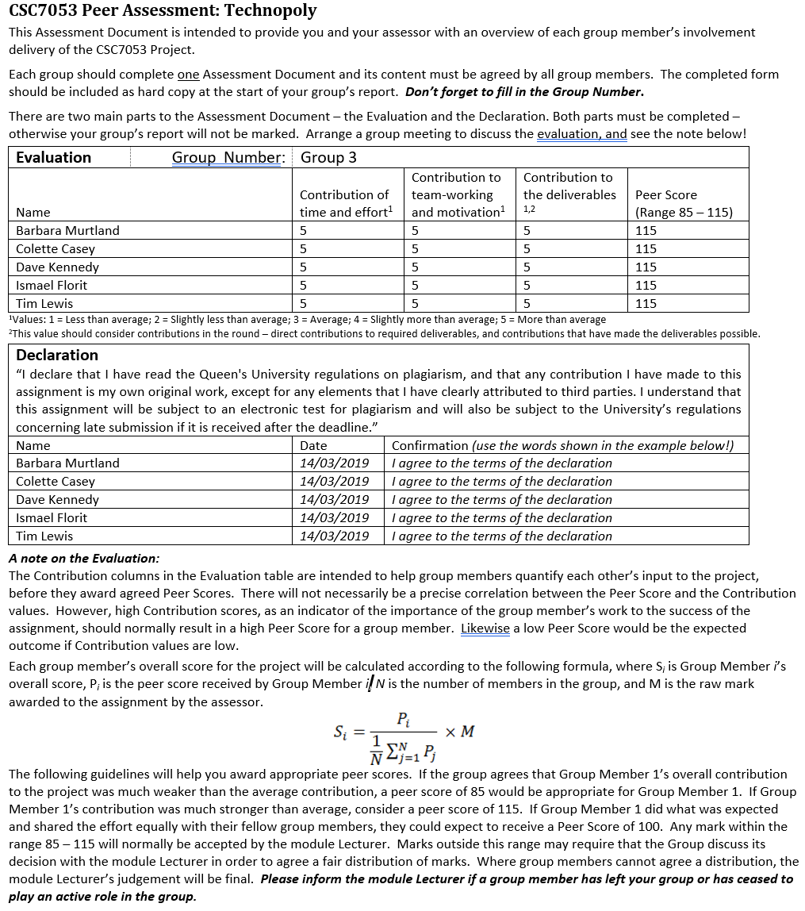

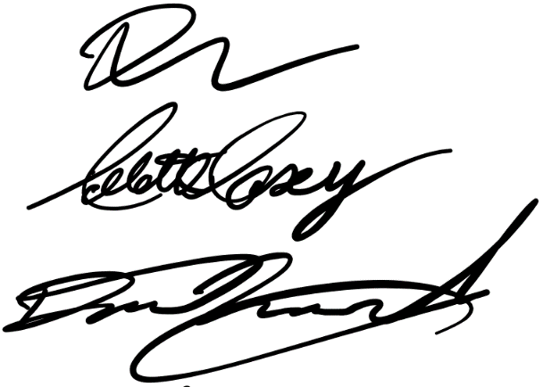

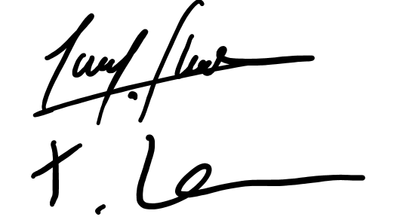

**Table of Contents**

1. Introduction…………..…………………………………………………………………………………………………………..4
2. Requirements Analysis ..…………………………………………………………………………………………………….4
   * 1. Game Guide & Graphical Representation of Board……………………………………4
     2. Use Case Descriptions……………………………………………………………………………….5
     3. Use Case Diagram……………………………………………………………………………………..11
3. Realisation………………….………………………………………………………………………………………………………12
   * 1. Sequence Diagram………………………………………………………………………………….…13
4. Design……………………………………………..…………………………………………………………………………….…..17
   * 1. Traceability……………………….. …………………………………………………………………… 17
     2. UML Class Diagram…………….. ………………………………………………………………..… 18
5. Conclusion……………………..……………………………………………………………………………..……………………21

**Appendix 1**

1. Photos of use case and sequence diagrams
2. Full user guide and graphical representation of board
3. Test Plan
4. Test Plan – Junit tests conducted
5. Glossary of Key Terms

**Appendix 2**

1. Weekly Team Meeting Minutes

Introduction

The aim of this report is to document the planning, design, development and implementation of a Monopoly style interactive game known as Technopoly. Technopoly has been developed in Java, using the console to create a textual interface. A use case driven development process was adopted by the team in order to effectively manage and meet the requirements established by the customer.

The group sought to follow the best practices of software engineering by adhering to the key stages in the software development process. The Requirements Analysis section details the group’s analysis of the system requirements using use case descriptions and a use case diagram. This proved to be a valuable tool for defining the Technopoly system’s external behaviour. The Realisation section of the report outlines how the most important use case descriptions were used to create detailed sequence diagrams which reflect the high-level interactions between use cases.

Finally, the Design section highlights how the group’s focus shifted from the requirements of the system to the structure of the Technopoly software, transforming the analysis model into a functioning game. The responsibilities of each object were considered in more detail. The UML Class Diagram illustrates the final design of the working Technopoly game. A key goal of the Design section was to ensure high cohesion and low coupling within the game system. A test plan was devised and JUnit tests were implemented alongside the development of the software, see Appendix 1. Regular scrum meetings were held and documented to keep development on track, see Appendix 2.

Requirements Analysis

The team met to fully discuss the uses cases which were needed, running through a mock up the game. The use cases were then split amongst the team to write and develop before being collated and referenced.

i. Game Guide and Graphical representation (TL, IF)

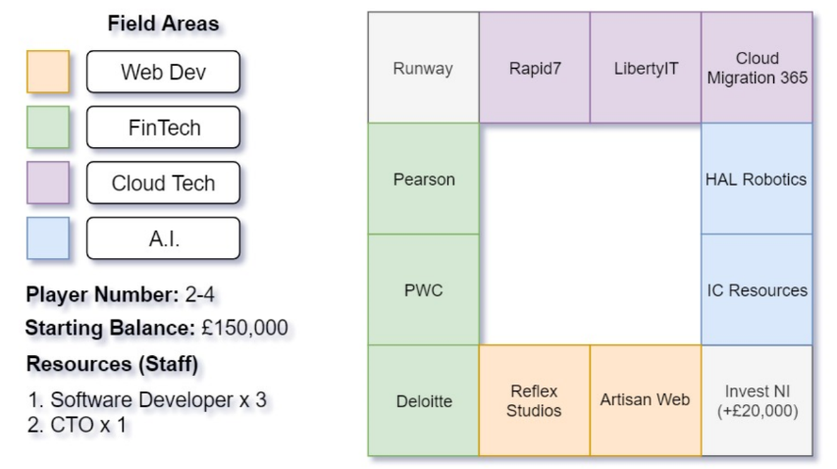

Figure 1 Technopoly Board

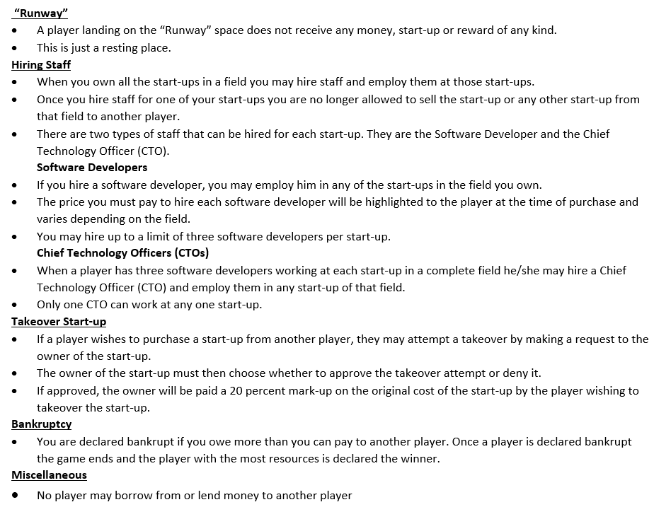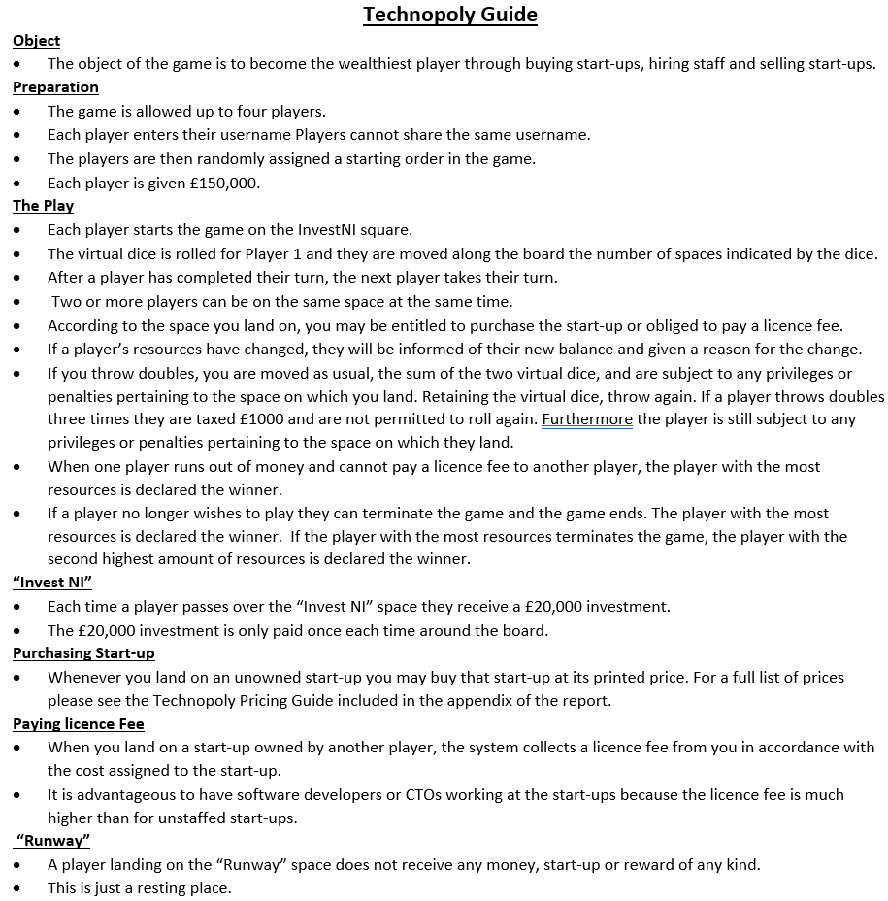

Figure 2 Technopoly Game Guide

ii. Use Case Descriptions (BM collated. CC, TL, DK, IF contributed)

The use cases below describe the externally visible behaviours and structures of Technopoly. Each use case represents a task or interaction with the game performed by the actor(s) listed. These descriptions therefore, will form the basis for the system requirements. Please refer to the Use Case Diagram. In order to assist the reading of the below descriptions all use cases have been listed numerically. All extension and inclusion points have been assigned a letter, red for Extension Points, blue for inclusions. Actors have been italicised.

|  |  |
| --- | --- |
| **Use Case 1** | **Starts Game** |
| **Summary** | Establish the number of players(2-4) and their names. Randomly generate the order of play. Game starts. |
| **Actors** | *Player1, Player2,* (*Player3, Player4* are optional) |
| **Triggers** | 2-4 players wish to set-up Technopoly |
| **Pre Conditions** | There are a minimum of 2 and a maximum of 4 players |
| **Post Conditions** | * The valid number of players selected is displayed. * A random order is generated.   The players can either view the rules [Use case 2 Views Rules] or press start to begin the game. |
| **Flow** | 1. The *player(s)* are prompted to enter the number of valid players(between 2 and 4 players) 2. The *players* will be prompted in turn to enter a valid name (2-15 characters) 3. Once all player names are added to the game a random order is assigned to the players and the game begins. |
| **Alternative Flow** | * At flow point 1:- If the number of players is invalid, the *player(s)* will be prompted again and reminded that the valid number of players is between 2 and 4 * At flow point 2:- If the name of the player is invalid or already exists in the game, the *player* will be prompted again and reminded that a valid name is between 2 and 15 characters(including – and ‘) excluding whitespace. |
| **Extension Points** | None |
| **Inclusions Points** | None |
| **Use Case 2** | **Views Rules** |
| **Summary** | The *player* views the rules of the game before selecting ‘Start Game’. |
| **Actors** | Player(s) |
| **Triggers** | [USE CASE 1 Start Games] After selecting entering a valid number of players and entering valid name the players can view the rules. |
| **Pre Conditions** | * The game has not yet started |
| **Post Conditions** | * The rules of the game are displayed. |
| **Flow** | 1. The *player* selects the “View Rules” option. 2. The system displays the rules of the game to the player(s). |
| **Alternative Flow** | The players do not select ‘View Rules’ in which case the only other option available to them is to ‘Start Game’. |
| **Extension Points** | None |
| **Inclusions Points** | None |
| **Use Case 3** | **Takes Turn** |
| **Summary** | *Player* rolls dice and moves to the corresponding space. Three options are then posed to the player |
| **Actors** | Player(s) |
| **Triggers** | The game starts OR the player before has ended their turn |
| **Pre Conditions** | * [USE CASE 1 Starts Game] :- The game is set up * It’s the *player* in question’s turn |
| **Post Conditions** | * [USE CASE 11 Ends Turn] :- The *player* must select ‘end turn’ once they have completed their turn. The next player will repeat this operation. |
| **Flow** | 1. The player is shown: Player Number, Name, Balance, Properties Owned including Staff, the dice score thrown and the space they have landed on. Eg, Player 1 | Joe Bloggs | £xx.xx | Owns: [AProperty, BProperty] | Rolled [2,6] | Landed on X. 2. The *player* is ‘moved’ to the corresponding space. Depending on the space landed on the *player* can: 3. Purchase Start-up [Extension D] 4. Pay Licence fee [Extension B] 5. The *player* can view menu [Inclusion A] |
| **Alternative Flow** | 1. At flow point 1 and 2:- If the *player* rolls a double (same value on both dice) the *player* is moved to the corresponding space. They finish that turn and take another go immediately. 2. At flow point 1 and 2:- If doubles is rolled three times in a row; on the third turn the *player* suffers a penalty (tax or jail depending on the game iteration) 3. At flow point 4:- If the *player* has insufficient funds to pay a Licence fee, then that *player* is declared bankrupt and the game is over. The player with the highest net worth is deemed the winner. [Extension C] |
| **Extension Points** | D. Purchase Start-Up – [Use Case 7]  B. Pay Licence Fee –[ Use Case 5]  C. Declares Bankruptcy – [Use Case 6]  A. Lands on Runway – [Use Case 4]  E. Passes Invest NI – [Use Case 8] |
| **Inclusions Points** | 1. Views Menu – [Use Case 9] |
| **Use Case 4** | **Lands on Runway** |
| **Summary** | Player lands on the ‘Runway’ field |
| **Actors** | *Players* |
| **Triggers** | The Player has moved onto the “Runway” field |
| **Pre Conditions** | * It’s the *player* in question’s turn [Use Case 3 Takes Turn] |
| **Post Conditions** | * The *player’s* turn continues |
| **Flow** | 1. The *player* lands on “Runway”. This space cannot be owned. No licence fee is applicable. |
| **Alternative Flow** | None |
| **Extension Points** | None |
| **Inclusions Points** | None |
| **Use Case 5** | **Pays Licence Fee** |
| **Summary** | The p*layer* lands on a space with a start-up owned by another *player*. The *player* must pay the appropriate licence fee to the other *player*. |
| **Actors** | *Players* |
| **Triggers** | A *Player* lands on a square owned by another *player*. |
| **Pre Conditions** | * It’s the *player* in question’s turn [Use Case 3 Takes Turn] * The start-up on the space is owned by another *player* * The *player* has sufficient funds to pay the licence fee |
| **Post Conditions** | * The *player’s* balance is updated to reflect paying the licence fee * The new balance is displayed by the system * The *player* has sufficient funds to continue to play (Balance >=0) |
| **Main Flow** | 1. The *player* lands on a square for a start-up owned by another *player* 2. The system displays the licence fee and the other *players* name/number 3. The *player* must have the funds to pay the appropriate licence fee 4. *Player’s* balance is reduced 5. *Other players* balance is increased 6. The updated balances for each player are displayed by the system |
| **Alternative Flow** | 1. At main flow point 3:- the *player* does not have sufficient funds to pay the licence fee [Extension C]. |
| **Extension Points** | C. Declares Bankruptcy – [Use Case 6] |
| **Inclusions Points** | None |
| **Use Case 6** | **Declares Bankruptcy** |
| **Summary** | *Player* is declared bankrupt by the system. |
| **Actors** | *Player(s)* |
| **Triggers** | The *player* lands on an start-up owned by another *player* without sufficient funds to pay the licence fee. |
| **Pre Conditions** | * It’s the *player* in question’s turn [Use Case 3 Takes Turn] * The *player* has landed on any owned start-up that is not their own [Use Case 5 Pay Licence Fee] * The *player* has less funds than necessary to pay a Licence Fee. |
| **Post Conditions** | * The player is declared bankrupt. The game ends and a winner is declared. |
| **Flow** | 1. The *player* lands on an owned start-up that is not his own. 2. When unable to pay the fee, the system declares the *player* bankrupt. 3. The system ends the game and declares the winner (player with most resources). |
| **Alternative Flow** | None |
| **Extension Points** | None |
| **Inclusions Points** | None |
| **Use Case 7** | **Purchase Start-up** |
| **Summary** | The *player* lands on a space with an available start-up. If they decide to purchase the start-up, they pay the listed price. If they buy all the start-ups in the same colour group(field), they have a tech monopoly (technopoly) and can charge double the listed license fee. |
| **Actors** | *Player*(s) |
| **Triggers** | *Player* lands on a new space with an available start-up |
| **Pre Conditions** | * It’s the *player* in question’s turn [Use Case 3 Takes Turn] * The start-up on the space is available to purchase * The player has sufficient funds to buy the start-up |
| **Post Conditions** | * The *player’s* balance is updated to reflect the purchase * The *player’s* properties are updated to list the company * The *player’s* properties are updated if they own a complete field |
| **Main Flow** | 1. The *player* lands on a space with an available start-up 2. *Player* decides to purchase start-up by selecting “Purchase” from the menu [Inclusion A] 3. The system checks the *player* has sufficient funds, then:    1. Reduces *player’s* balance by the listed price    2. Adds the start-up to the *player’s* list of companies    3. Displays a message to confirm the purchase and the new balance   4. The *player* can either return to the menu/end their turn [Extension H] |
| **Alternative Flow** | 1. At main flow point 1:- The *player* decides not to purchase the start-up, Views Menu and ends turn [Inclusion A and Extends H] 2. At main flow point 3:III:- If the purchase completes the *player’s* ownership of a colour field, the system will display a message to announce this. The player is brought to the menu [Inclusion A] 3. At main flow point 3:- The *player* does not have sufficient funds. The System displays a warning message. The player cannot purchase the space. Player must end their turn. [Extension H] |
| **Extension Points** | H. Ends Turn [Use Case 11] |
| **Inclusions Points** | 1. Views Menu - [Use Case 9] |
| **Use Case 8** | **Passes Invest NI** |
| **Summary** | The *player* receives a £20,000 investment each time they are on or pass the Invest NI space.  Their balance is updated to reflect the changes |
| **Actors** | *Player* |
| **Triggers** | *Player* is on or passes the Invest NI space |
| **Pre Conditions** | * The game has been started [Use Case 1 Starts Game] * It is the *player’s* turn [Use Case 2 Takes Turn] |
| **Post Conditions** | * The *player’s* balance updates to reflect an investment of £20,000 |
| **Main Flow** | 1. The *player* is on or passes the Invest NI space 2. The player receives an investment of £20,000 |
| **Alternative Flow** | None |
| **Extension Points** | None |
| **Inclusions Points** | None |
| **Use Case 9** | **Views Menu** |
| **Summary** | Player views menu, which describes the options available to take during their turn. |
| **Actors** | *Player*(s) |
| **Triggers** | * It is the *player’s* turn [Use Case 2 Takes Turn] * Player has finished any actions other than “Quits Game”. |
| **Pre Conditions** | * It is the *player’s* turn [Use Case 2 Takes Turn] * The player has ‘rolled’ and if necessary paid any licence fees applicable |
| **Post Conditions** | * Player will either perform the selected action or quit the game. |
| **Flow** | 1. The *player* views the menu. 2. The player may choose any option on the menu: 3. Purchases Start-up – [Extension D]. 4. Takes Over Start-up – [Extension F]. 5. Hires Staff – [Extension I]. 6. Ends Turn – [Extension Point H]. 7. Terminates Game – [Extension G]. |
| **Alternative Flow** | None |
| **Extension Points** | D. Purchases Start-up – [Use Case 7]  F. Takes Over Start-up – [Use Case 12]  I. Hires Staff – [Use Case 10]  H. Ends Turn – [Use Case 11]  G. Terminates Game – [Use Case 13] |
| **Inclusions Points** | None |
| **Use Case 10** | **Hires Staff** |
| **Summary** | *Player* hires a new member of staff for their Start-up space. The player must own all spaces in that field. They can then hire a software developer OR if three developers are present on the space, then they can purchase one CTO to place on that space. Each space can only have a maximum of three developers OR one CTO present. |
| **Actors** | *Player* |
| **Triggers** | *Player* selects ‘Hire Staff’ from the menu[Use Case 9 Views Menu] |
| **Pre Conditions** | * It is the *player’s* turn [Use Case 2 Takes Turn]. * The player is on any space. * The player owns all corresponding spaces relating to that field. * The player has sufficient funds to employ the corresponding Developer/CTO. * The number of staff on the relevant field will not exceed the limit of staff once this hiring process is complete. |
| **Post Conditions** | * Player will have relevant amount of money debited from their account. * Player will have a new member of staff on the desired field. * Player will be shown new account balance. * Player will be told they have hired the relevant staff member at the relevant start-up. |
| **Flow** | 1. The *player(s)* selects the ‘Hires Staff’ menu option. 2. The player selects the area they wish to develop. 3. The player confirms they wish to proceed with the hiring of staff [Inclusion D] 4. The relevant amount of money is deducted from the players account. |
| **Alternative Flow** | 1. At flow point 1:- If the player has insufficient funds to hire a member of staff at this start up a message is displayed stating so and player is returned to view menu [Use Case 9 Views Menu]. 2. At flow point 2:- If the player already has too many staff hired at the startup in question; a message is displayed stating so and the player is returned to the Views Menu [Use Case 9 Views Menu]. |
| **Extension Points** | None |
| **Inclusions Points** | D. Verifies Choice [Use Case 14] |
| **Use Case 11** | **Ends Turn** |
| **Summary** | A player ends their turn in the game. The game continues. |
| **Actors** | Player(s) |
| **Triggers** | The *player* selects the “end turn” option from the menu. |
| **Pre Conditions** | * It is the *player’s* turn [Use Case 2 Takes Turn]. * The *player* has already ‘rolled’ the dice and landed on a new space. * If required, the player has paid the necessary licence fee to another *player*.[Use Case 7 Pays Licence Fee] * The *player* has selected the “view menu” option [Use Case 9 Views Menu]. |
| **Post Conditions** | * The player’s turn ends * The system produces a message declaring that it is the next player’s turn. |
| **Flow** | 1. The *player* chooses the “view menu” option. [Inclusion A] 2. The *player* chooses the “end turn” option.[Extension H] 3. The system asks the *player* if they are sure they want to end their turn. [Inclusion C] 4. The *player* chooses the “yes” option. 5. The *player’s* turn ends. |
| **Alternative Flow** | 1. At flow point 4:- The player chooses the “No” option and they are returned to the menu. Their turn has not ended. |
| **Extension Points** | H. Ends Turn [Use Case 11] |
| **Inclusion Points** | C. Verifies Choice [Use Case 14]  A. Views Menu [Use Case 9] |
| **Use Case 12** | **Takes over Startup** |
| **Summary** | Player stages a Takeover, offering the initial price of the start-up(they wish to Take Over) plus 20% on top. Takeovers need to be agreed by **both** parties. |
| **Actors** | *Players (Always 2 players)* |
| **Triggers** | The *Player(whose turn it is)* has selected the “Trades Start-up” option on the Menu. |
| **Pre Conditions** | * It is the *player* who wishes to perform the takeover’s turn – [Use Case 3]. * The player selects “Takeover Start-up” option from the play menu. |
| **Post Conditions** | * The current player has the required money for the transaction removed from their inventory. * The relevant player, who sold their start-up with the current player, has the start-up in question removed from their inventory.(If they agree to the Take Over). * The current player gains the Start-up from the other player and it is added to the current players inventory. * The relevant player, who sold their start-up, gains the relevant amount of money and it is added to their inventory. |
| **Flow** | 1. The current *player* selects the other player they wish to purchase a start-up from in a sub menu (each player is numbered, current player is not shown in sub menu). 2. The current player selects the start-up they wish to acquire from the previously selected player from a sub menu (each owned start-up is numbered). 3. The current player is prompted with a message displaying the cost of the property they are about to purchase and asked if they wish to proceed.[Inclusion F] 4. The other player involved in the transaction is asked to confirm the sale of said startup. [Inclusion F] 5. The trade is completed. 6. The current player is shown the Menu – [Use Case 9] |
| **Alternative Flow** | 1. At flow point 1:- The current player may choose to cancel the takeover from the provided sub menu.    * Current player Views Menu [Use Case 9]. 2. At flow point 2:- The current player may choose to cancel the takeover from the provided sub menu.    * Current player Views Menu [Use Case 9]. 3. At flow point 3:- The current player may choose to cancel the trade from the provided verification message.    * Current player Views Menu [Use Case 9]. 4. At flow point 4:- The other player involved may choose No when prompted if they wish to proceed with the takeover.    * Current player Views Menu [Use Case 9]. |
| **Extension Points** | None |
| **Inclusions Points** | F. Views ‘Verifies Choice’ [Use Cases 14]. |
| **Use Case 13** | **Terminates Game** |
| **Summary** | A player terminates the game and the player with the most resources is declared the winner. |
| **Actors** | Player(s) |
| **Triggers** | The *player* selects the “terminate game” option from the menu. |
| **Pre Conditions** | * It is the *player’s* turn [Use Case 2 Takes Turn]. * The *player* has already ‘rolled’ the dice and landed on a new space. * If required, the *player* has paid the necessary licence fee to another player.[Use Case 7 Pays Licence Fee] * The *player* has selected the “view menu” option [Use Case 9 Views Menu]. |
| **Post Conditions** | * The system produces a message declaring that a *player* has terminated the game and the game is over. * The *player* with the most resources is declared the winner. |
| **Flow** | 1. The *player* chooses the “View Menu” option.[Inclusion A] 2. The *player* chooses the “Terminate Game” option. 3. The system asks the *player* if they are sure they want to terminate the game. [Inclusion E] 4. The *player* chooses the “yes” option. 5. The game is terminated, and the winning *player* is displayed |
| **Alternative Flow** | * At flow point 3:- The player chooses the “No” option and is returned to the menu. |
| **Extension Points** | None |
| **Inclusions Points** | A. Views Menu [Use Case 9]  E. Verifies Choice [Use Case 14] |
| **Use Case 14** | **Verifies Choice** |
| **Summary** | The *player* verifies a selected action from the menu presented to them. They can only select yes or no. No returns them to the menu. Yes carries out the required action. |
| **Actors** | *Player(s)* |
| **Triggers** | * The *player* attempts to use the “Purchase Start-up” option.[Use Case 7] * The *player* attempts to use the “Takes Over Start-up” option.[Use Case 12] * The *player* attempts to use the “Terminate Game” option.[Use Case 13] * The *player* attempts to use the “Ends Turn” option. [Use Case 11] * The *player* attempts to use the “Hires Staff” option. [Use Case 10] |
| **Pre Conditions** | * The *player* attempts to use the “Purchase Start-up” option.[Use Case 7] * The *player* attempts to use the “Takes Over Start-up” option.[Use Case 12] * The *player* attempts to use the “Terminate Game” option.[Use Case 13] * The *player* attempts to use the “Ends Turn” option. [Use Case 11] * The *player* attempts to use the “Hires Staff” option. [Use Case 10] |
| **Post Conditions** | The selected option is confirmed and the system notifies the *player* with the corresponding confirmation message. |
| **Flow** | 1. The player attempts to use one of the following options in the menu: 2. “Purchase Start-up”[Use Case 7] 3. “Takes Over Start-up” Use Case 12] 4. “Terminate Game” Use Case 13] 5. “Ends Turn” [Use Case 11] 6. “Hires Staff” [Use Case 10]   2. The system prompts the user to verify the selected choice.  3. The *player* confirms the choice.  4. The system displays a confirmation message to the *player.* |
| **Alternative Flow** | 1. At flow point 3:- The *player* may choose to cancel the selected choice.   * + Current player Views Menu [Use Case 9]. |
| **Extension Points** | None |
| **Inclusions Points** | None |

iii. Use Case Diagram (BM/IF drew. TL, DK, CC contributed)

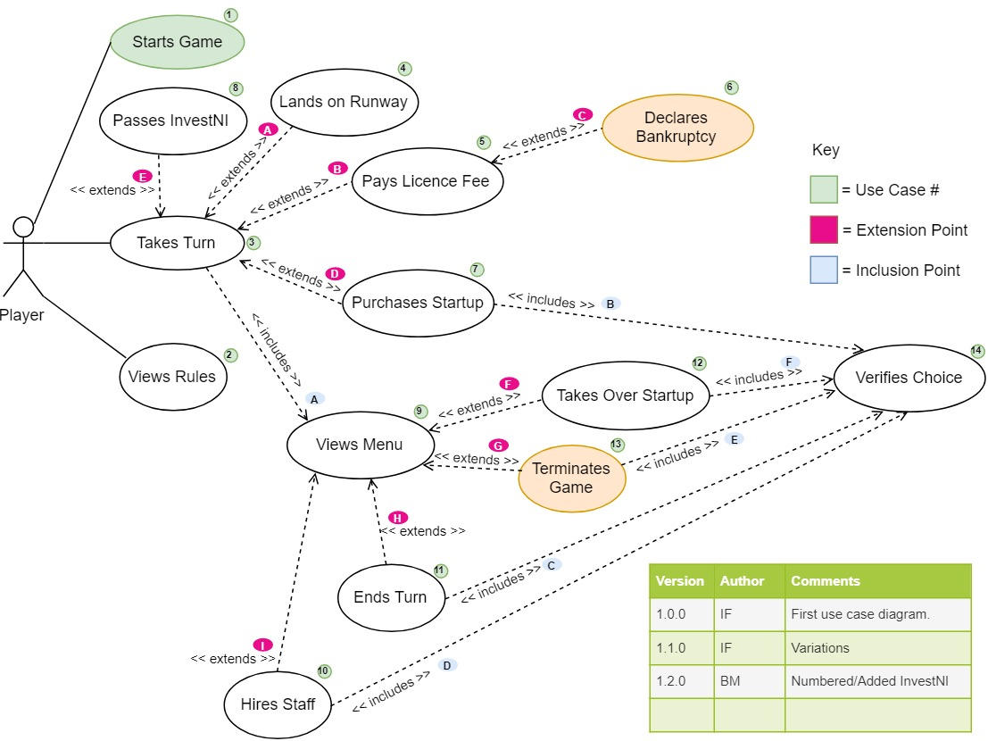

The final use case diagram was created to reflect the use cases and clarify the requirements of the system. It details the different interactions between use cases and the system as a whole, while also setting out the boundaries for the game system. One actor has been used to represent each player. It was noted that a Domain Model could have been implemented to further the planning and analysis stage. However due to time constraints on the project this was deemed unnecessary.

Realisation (TL/BM led. DK/CC/IF contributed.)

Upon completion of the use cases and use case diagram, sequence diagrams were developed in order to fully realise the system design before development. The diagrams below highlight the main object interactions, arranged in time sequence, within the Technopoly system. They focus on lifelines and the objects that interact simultaneously, as well as the messages passed between them, before the lifeline ends or is destroyed.

The group focused on the key events in the use case descriptions to realise in their sequence diagrams:

• TurnEngine was envisioned as being made up of Use Case 3 [Takes Turn]. Turn Engine continues until it reaches Use Case 13 [Terminates Game] or Use Case 11 [Ends Turn]. Yet by its nature it also contains elements from Use Cases 7 [Purchase StartUp], 5[Pay Licence Fee], 6 [Declares Bankruptcy] and 9 [Views Menu].

• GameAdmin was a realisation of Use Case 1 [Starts Game] and Use Case 3 [Views Rules].

• UserInput was a realisation of Use Case 14 [Verifies Choice]. Despite initially being designed solely to verify a user’s choice, upon further development it was decided that this class should manage all user input.

i. Sequence Diagrams

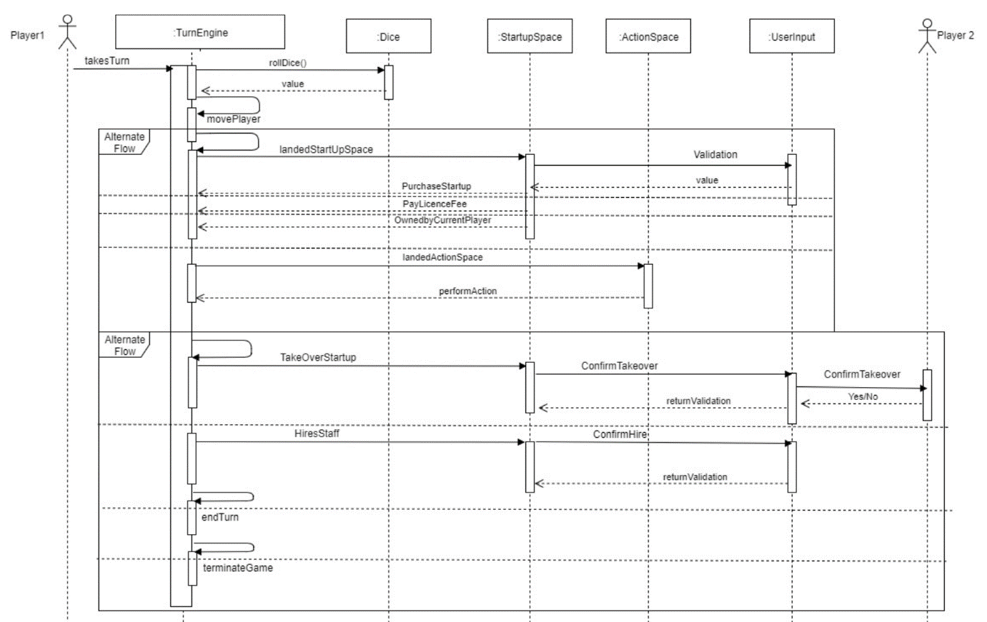

Figure 3 Turn Engine Sequence Diagram

The TurnEngine is the largest object within the Technopoly game. All behaviours that are contained within a turn are controlled by the TurnEngine, while all behaviours relating to the management of each turn are controlled by the GameEngine object. In order to control all the behaviour of each turn, the TurnEngine is required to interact with several other objects within the Technopoly game, as shown in figure 4. For example, the TurnEngine is responsible for rolling the dice and moving players around the board. In order to achieve this, it must interact with the Dice object during each player’s turn before it can move a player around the board.

Having moved a player, the TurnEngine must then interact with the StartupSpace object to determine whether a licence fee needs to be paid or if a start-up is available for purchase. The TurnEngine also checks the StartupSpace object to see if a startup can be developed, enabling the hiring of staff.

The TurnEngine contains all the functionality relating to the in-game menu. As a result it must interact with the UserInput object throughout the game in order to act on each player’s decisions. Each time the menu is printed to the console screen, the TurnEngine makes a call to the UserInput object. If a player wishes to terminate the game, for example, they choose the “Terminates Game” option from the menu and that value is then returned to the TurnEngine by the UserInput object. Once a player has requested to terminate the game, the TurnEngine calculates the winner, and outputs a message to screen.

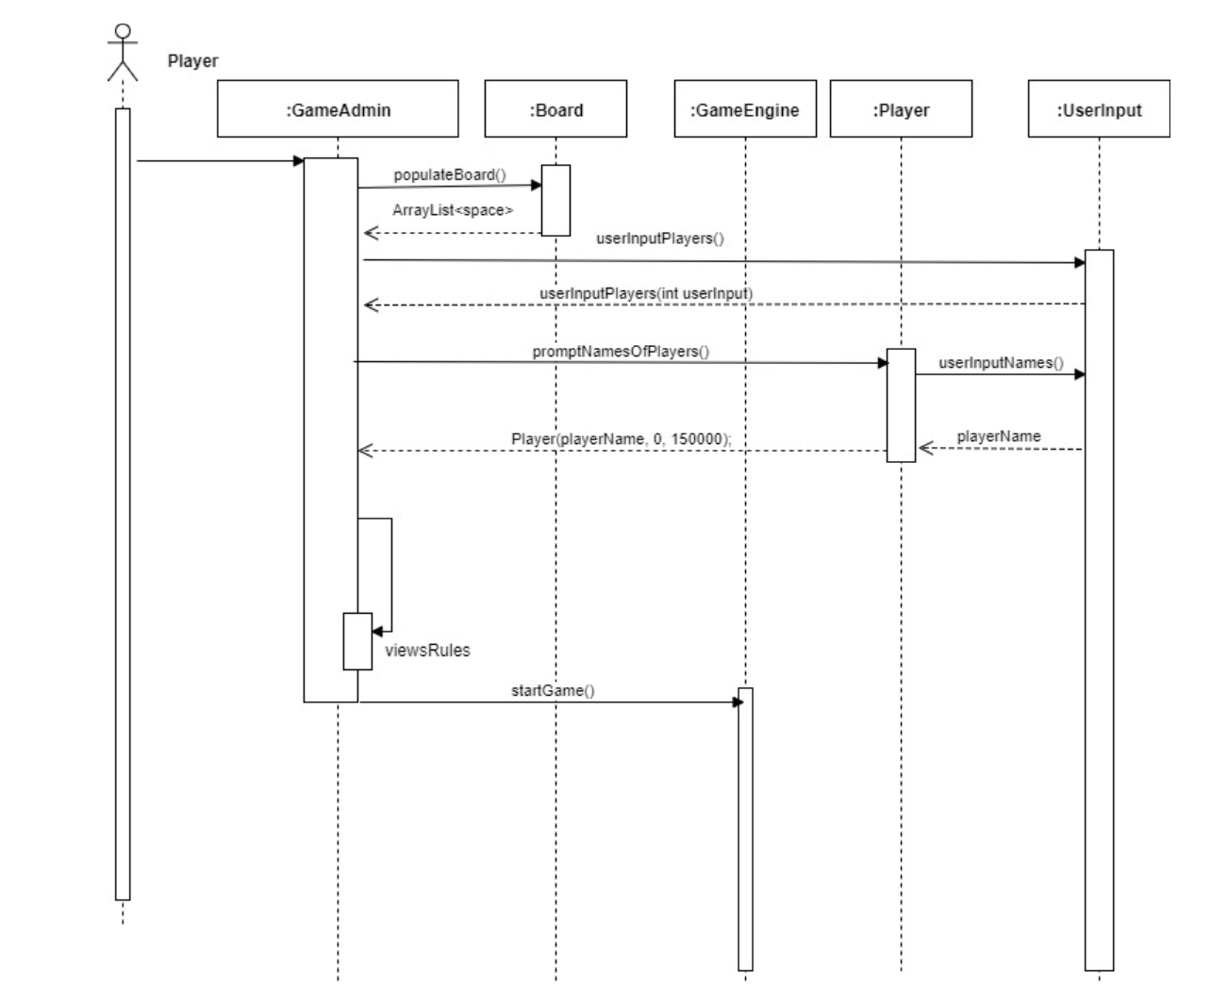

Figure 5 Game Engine Sequence Diagram

As figure 5 shows, the entire Technopoly game is launched from the GameAdmin object. Once instantiated, GameAdmin begins by interacting with the Board object to populate the virtual board with all twelve spaces before the actual game begins. After this, the GameAdmin object then makes a call to the UserInput object to allow the player setting up the game to establish the number of players, before then making another call to UserInput to get each player’s username.

After populating the board, assigning the number of players and individual usernames, GameAdmin then instantiates the GameEngine object through the startGame() method and the game begins.

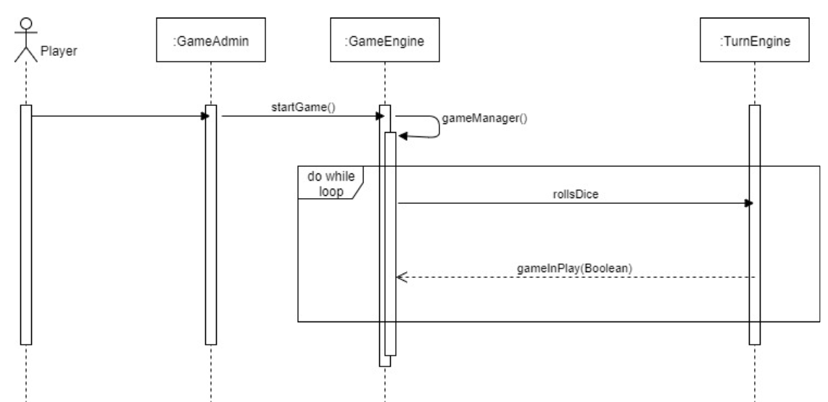

Figure 6 Game Admin Sequence Diagram

Figure 6 reflects one of the major design decisions of the Technopoly project – the GameEngine object. Having initially decided that the management of each turn would be carried out by the TurnEngine object it was then agreed that it would be better to create a separate object, known as GameEngine, that was solely responsible for managing each turn. This meant that all behaviour associated with a turn would be kept within the TurnEngine, whilst the management of each turn and round would be controlled by the GameEngine object.

As Figure 6 highlights, the GameEngine is instantiated by the GameAdmin object through the startGame() method. The GameEngine manages the game through the gameManager() method which is designed to monitor and store the following: the count of the round the game is on, which player’s turn it is to roll the dice (via the rollDice() method in the TurnEngine ) and how many turns have been completed. Furthermore, the gameManager() method tracks doubles, and checks if a player has rolled three in a row.

The gameManager() method interacts with the TurnEngine object by continuously calling the rollDice() method from within the TurnEngine, while the gameInPlay Boolean returns true. The gameManager will continue to generate a new round after each player has taken their turn as long as no player has run out of resources or terminated the game.

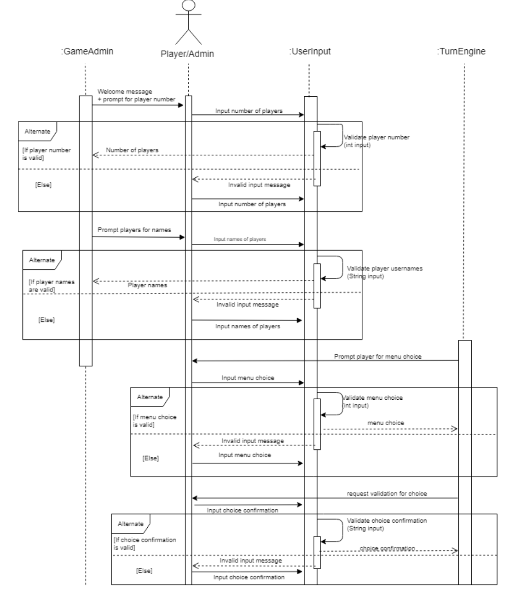

Figure 7 UserInput Sequence Diagram

The UserInput object is concerned with scanning and validating a player’s input before returning the value to either the GameAdmin or TurnEngine objects. The UserInput object is essential for all interactions between players and the system throughout the game.

As highlighted in figure 7, the first instance of UserInput within the game is during initial game set up. The player setting up the game is asked to input the number of participating players, a method within the UserInput object is called from the GameAdmin object and scans in the user’s response. It is here that the function of UserInput is vital, as the user’s response will be validated before being returned to the GameAdmin object. If the user inputs an invalid value, the UserInput object does not return the value, instead asking the user to re-enter the value until a valid answer is entered. This system of validation is repeated throughout the UserInput object for each interaction between the player and the system.

Design

**i. Traceability table**

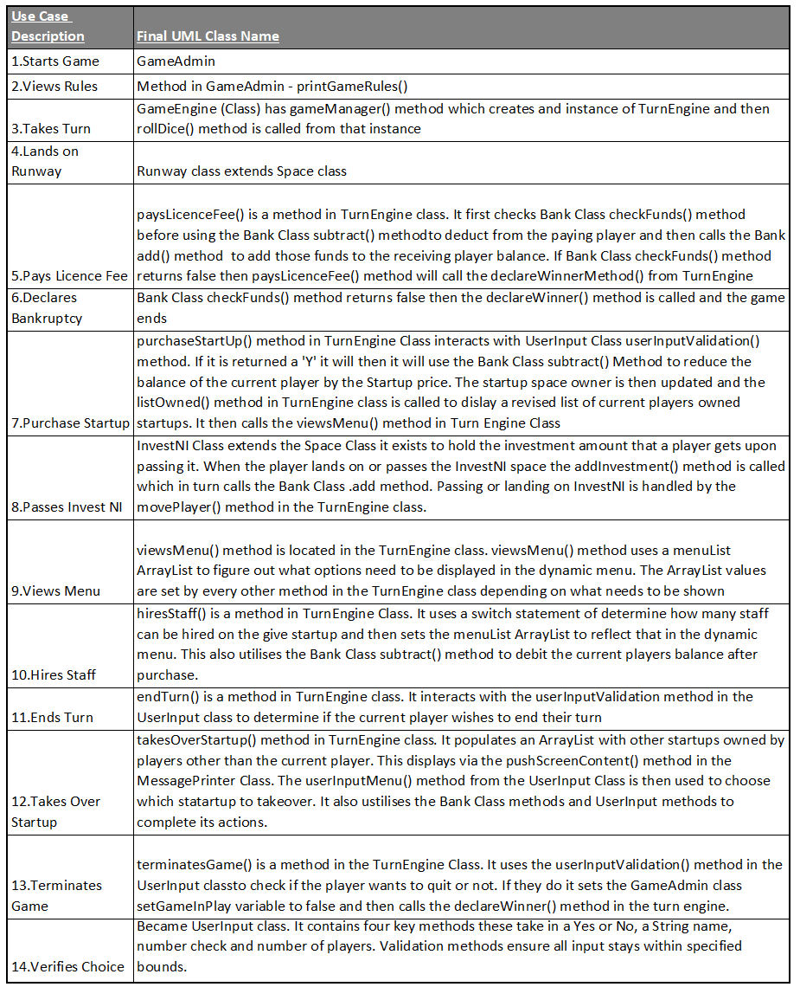

­ii. UML Class Diagram (DK/IF/CC lead but the whole team contributed fully to the design and implementation of the game)

The Group 3 UML Class diagram gives an overview of the Technopoly system’s working components.

­

Figure 8: Group 3 Technopoly UML Class Diagram

Initial design of the game involved the discovery of candidate classes through noun spotting of the Game Guide and Game Requirements documents. Whilst many of the classes had already been accounted for, some nouns gave way to new classes. Some noteworthy considerations included:

* **Tax**: it was decided that rolling three doubles in a row would incur a tax of £1,000.
* **Winner**: the group considered implementing a leader board system and decided that it should be a feature of a future iteration of the game.
* **Takeover**: to incentivise players to part with their startups during takeover attempts, it was agreed that a 20% markup price should be attached to all startups upon their purchase. This would improve the playability of the game.

The class diagram shown in Figure 8 corresponds closely with the final implementation of the Technopoly game. Principles of maintenance and extensibility were constantly considered throughout the design process. This is evidenced by the use of the Enum data type in StartupSpaceValues, wherein each value holds its own information. The board size is dynamically generated depending on however many Enum values are listed. Having the values in a separate list makes them more accessible and easier to maintain if updates or changes are required. For extensibility, the size of the list can simply be increased if future iterations of the game require more spaces on the board.

In the class diagram, shows a composition relationship between the spaces and the board.

The spaces can only belong to one board at a time and will be destroyed when the board is terminated at the end of the game.

Figure 9: Examples of Composition and Inheritance Relationships in Technopoly UML Class Diagram

Generalisation (inheritance) has also been used to construct the different types of spaces on the board. The general superclass Space is placed at the head of the open arrow and is extended by the more specialised classes StartupSpace, InvestNI and Runway. Each subclass ‘is a kind of’ space on the Technopoly board (p157, Priestly). Using this relationship improves ease of maintenance and would allow extensibility by making it simpler to develop other subclasses in the future.

While coupling is useful in these circumstances, it is loose and limited to this one area of the diagram; the overall design aimed to achieve a higher degree of cohesion. In doing so, careful consideration was given to the responsibilities each class would have and how well they would fit together. When a key class such as TurnEngine became expansive during development, a new GameEngine class was created to ensure a better division of responsibilities. This also helped make the code easier to develop and maintain.

Figure 10: Closer look at TurnEngine and GameEngine in the Technopoly UML Class Diagram

The GameEngine class enables the system to keep track of each round, turn and how many doubles the current player has rolled in a row. The round counter was added with future extensibility in mind as very little extra work would be required to add a round limit to any game. This idea fuelled further adaptations in other classes, such as the StartupSpace class. This class has an alternative constructor, which may be used in a future version of the game, to assign ownership of startups to players at the beginning of the game. This could lead to a ‘Quick Game’ option being given at the start of the program, where players are already assigned a certain amount of assets and a round limit is set.

Other important design considerations include:

* The SecureRandom class being used in the Dice class, as it is more secure and there is less chance of returning the same number twice.
* A separate UserInput class to handle all user input operations. This furthers the extensibility and maintainability by limiting all user messages to one class. There are four methods in this class to deal with different types of input from the user and another four additional methods to handle validation of the inputs. More types of input could be accommodated with little work and the existing methods in the UserInput class can be called by any new class or method easily.
* The viewsMenu method in the TurnEngine class is dynamic, only showing the options available to the user/player at the appropriate times. The menu will not display the option to purchase a startup that is already ownedand will not display the option to perform a takeover if no other player owns a startup.
* The value of startups increase in price when purchased. This offers a financial incentive to the potential seller during a takeover attempt.
* A separate Bank class to process all balance transactions.
* A separate MessagePrinter class to handle formatting of key message outputs. For example, the name of the player’s turn along with their balance.

An option to view the game rules at the start of the game was included to provide the user/player with everything they need while in the domain of the game. A map of the board would be an obvious future inclusion if implementing a GUI.

The language was carefully considered to be playful at big decision points, such as the termination of the game and for points of no control such as being taxed. For the vast majority of the game the language is purposely direct, informative and sparing. It was decided that the user should not feel like they are overloaded with messages but rather are able to understand where they are and what they own at a glance.

Ideally, given more time, there would be further de-coupling of the TurnEngine class. Due to time constraints and with a willingness not to veer too far from the initial concept design, the group included the declareWinner(), purchaseStartup() and hiresStaff() methods in the TurnEngine.

However, the group feels these methods may be better represented as their own classses in a future iteration of the game, as they perform a complex function in their own right.

**Conclusion**

By following the process of requirement analysis, realisation and design, Group 3 were able to test and implement a working Technopoly game with the appropriate functionality required by the customer. The theme has a technology twist based on local companies and investors. All the final functionality of the working game can be viewed in the accompanying video attached with this report. In the meantime, Group 3 invite you to become the actor in their game of Technopoly. Try for a triumph by becoming the wealthiest player through buying and selling, hiring and firing at local technology companies.

<https://gitlab.eeecs.qub.ac.uk/csc7053-1819/csc7053-1819-g3>